

# NHS Pensions

# NHS Pensions Online (POL) Guide

# 11. ESR Mid-Year Contribution Rate Changes

This form is auto generated by the National Health Service Business Services Authority (NHSBSA) when a mid-year contributions rate change is received via the Electronic Staff Records (ESR) system.

To enable correct validation checks to be made against the employees’ contributions paid, the NHSBSA need to know the amount of contributions that relate to each contribution rate period within the financial year.

Access to this new form is shown on the following screen example:

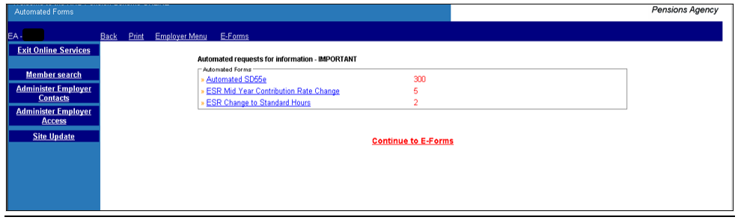

This page also shows the number of outstanding requests you have for which the NHSBSA are awaiting information.

Once this link is selected you will be presented with a list of your members for whom ESR has submitted a mid-year contribution rate change.

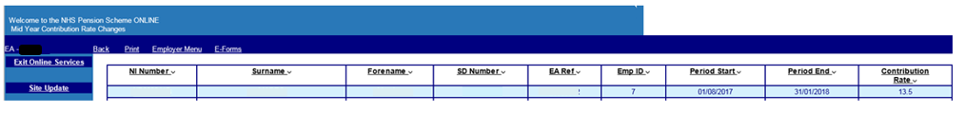

Select a member by clicking on the relevant line.

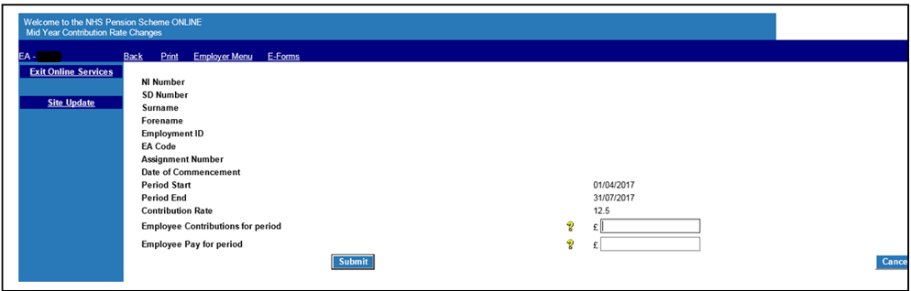

You should insert the requested information onto the e-form and submit it for processing.

If mismatching contributions and pay details are inserted you will receive on-screen messages as follows:

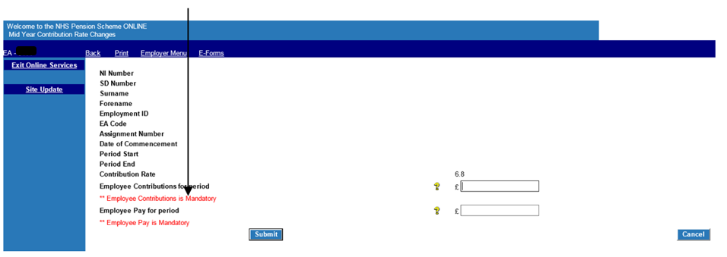

Once successfully submitted this additional information is then held by the NHSBSA ready for processing when the cyclic update or termination details are received.